Barrington Presents Awards to Marriott and Beresford-Hartwell

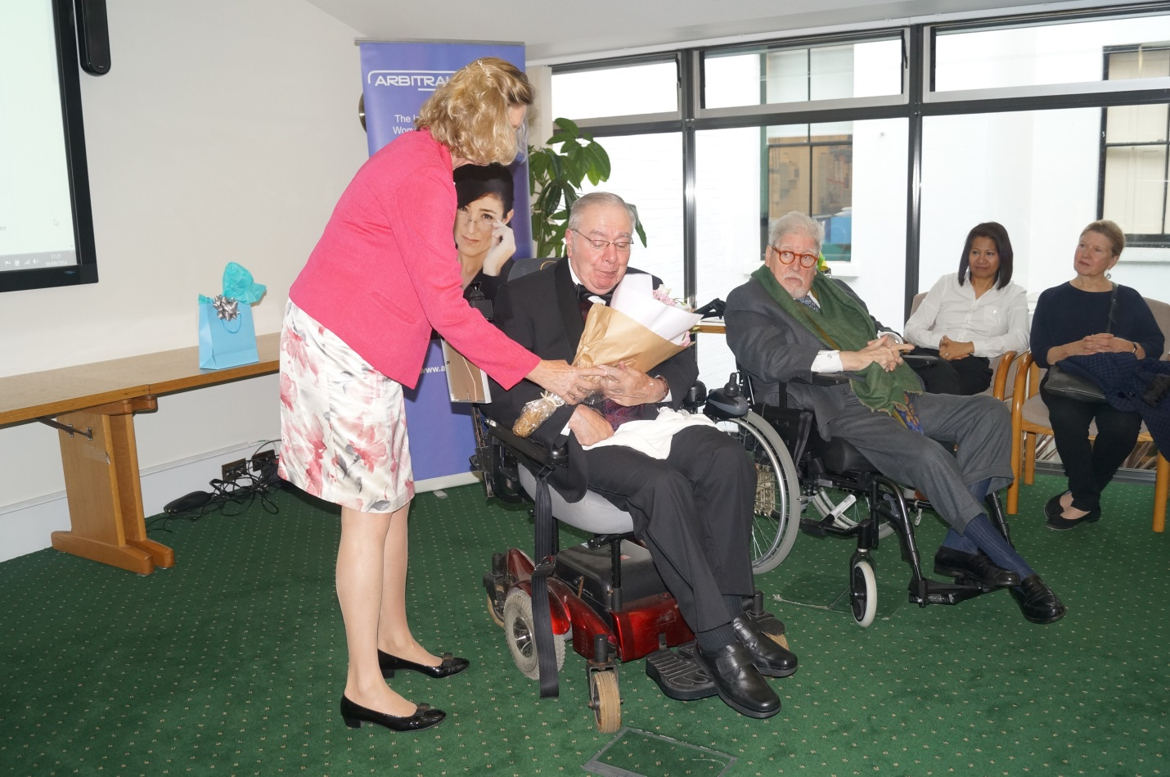
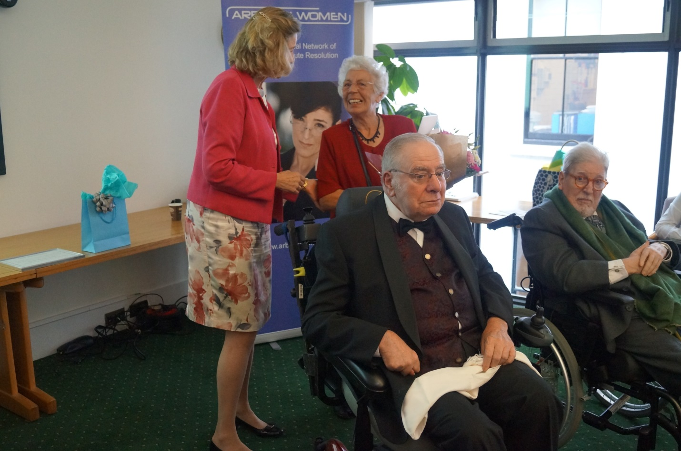
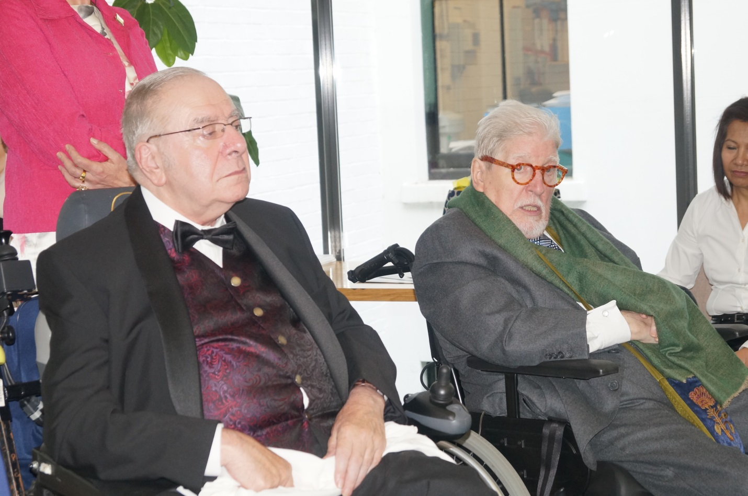

On September 9 2014 at the London, England Headquarters of the Chartered Institute of Arbitrators, Louise Barrington founding Co-president of ArbitralWomen, presented the organisation’s 2014 Honorable Man Awards to Arthur Marriott QC and Geoffrey Beresford Hartwell, as co-Founder Mireze Philippe, current President Rashda Rana, and scores of other members and friends looked on. Following is the text of her address.

HONORABLE MAN PRESENTATION
As you all know, ArbitralWomen is an organization OF women and FOR women. All our members are women. It grew from the need of women to engage WITH OTHER WOMEN in solidarity and in support. ArbitralWomen was a response to what we perceived as the “old boys’ network”, where many professional relationships were – and are – forged, far away from the law offices and arbitration hearing rooms. The after dinner cigars, the weekly golf foursomes, the camaraderie of the locker room – these were all off limits to women. We felt the need for a counterbalance. Had we made a co-ed group, it would simply not have had the same personality or effect for which we are known today.
Nevertheless, we are quick to appreciate the many contributions that some of our male colleagues have made. These are men who, by their words, and more importantly by their actions, have shown their appreciation of us women, and who have supported our ideals and our objectives.
This was the origin of the Honorable Man Award, which was inaugurated at our Paris meeting in 2010. In theory we present the HM Award once a year, but we aren’t rigid about it. Last year we didn’t give out an HM Award, but spent several months deciding on who would be just the right person to get it. After nominations from the AW members, much discussion of the merits of a number of nominees, we finally decided to give two awards this year. Don’t think of this as sharing one award, because each of these Honorable men is receiving a whole award – reflecting very different careers and styles, but each providing an invaluable contribution to the progress of women in dispute resolution.
This afternoon we are delighted to be here at Bloomsbury Square, to honour these two gentlemen for their dedication to helping women get ahead in what 25 years ago was a sea of gray suits. We are pleased to have these two gentlemen with us today, Arthur Marriott and Geoffrey Beresford Hartwell.

Now – without attempting to sum up two stellar careers of several decades each, I want to say just a little about each man – to give you an idea about what they have done to help us over many years.

Turning first to ARTHUR MARRIOTT QC:
Arthur, it was your friend and admirer Karen Mills who nominated you for this award. Karen is a founding member of ArbitralWomen and this year is our Treasurer. She could not join us from Jakarta, but she sent me this message to deliver to you:
“ I would be greatly surprised if there is not more than one woman here today whose expertise and legal career benefited directly from her association with Arthur Marriott. Of course all of us have benefited indirectly because Arthur was one of the most outspoken adversaries of the "glass ceiling". He was well known, in his addresses across the globe, to condemn it, in his inimitable manner, invariably culminating in a short, forceful pronouncement that would shake your mind - and then inhabit it.

Many of our profession's leading women were supported and nurtured and guided by Arthur throughout his Oddessy through the legal world. Arthur became a solicitor in 1966, worked as a part-time criminal judge, and was one of the first two solicitors to be honoured with the title of Queens Counsel. His journey both commenced and culminated at Gray's Inn, and including such prestigious firms as Leboeff Lamb, later Dewey Lebouff), Debevoise, Wilmer Cutler . And we mustn’t forget Marriott Masons, a firm he set up with Masons in Hong Kong and which has now expanded, as Pinsent Masons, into mainland China. He’s a Chartered Arbitrator, a member of the governing council of ICCA and a respected author. There really isn’t time to go through all of Arthur’s achievements and contributions to professional organisations, but nearly everyone in this room knows him anyway.

Indeed Arthur has been an inspiration for many men as well as women. He never made a distinction (professionally anyway), but always treated women with the same regard and respect as he did men, his reactions depending on their intelligence, diligence and wisdom -- never on gender. He continually respected and promoted quality – in whichever gender he happened to find it.

Unfortunately, at the peak of his career, Arthur suffered a serious heart attack while working in Rio de Janeiro, a bit over a year ago. As he sits with you to receive this Award, I wish Arthur a speedy recovery and hope soon to hear that you in fine fettle and back at work. “

I join with Karen, on behalf of all of us here in this room, and on behalf of so many who are not, to present Arthur Marriott QC with the 2014 Honorable Man Award.

I turn now to GEOFFREY BERESFORD-HARTWELL
We are this year celebrating the 20th anniversary of the origin of ArbitralWomen, although in fact that very first dinner in Paris was late in 1993, so we are now nearly 21 years old, and have “come of age”. This is therefore the perfect moment to acknowledge Geoffrey.
Geoffrey came to arbitration through his original career as Mechanical Engineer in the maritime field, that most male of bastions. In a career spanning half a century has been president of the society of construction law and chairman of the Chartered Institute of Arbitrators. Despite a physical setback some years ago, Geoffrey has resumed his career and continues to act as a consultant, and arbitrator and adjudicator.
I met Geoffrey when he and a few others recruited me to the CIArb in 1992. Shortly after, he heard about a study I had done about women in international arbitration (or the lack thereof!), and he invited me to present my findings at the Institute’s conference in Boston. For me personally it was a thrill – my first on-stage appearance in an international setting. Up there with my then boss, Pierre Lalive, who wondered what I could possibly have to say. Unlike dear Pierre, who didn’t see a problem, Geoffrey was aware of the exclusion of women, and what’s more, he saw a way to combat it. That first invitation - and the inclusion of my paper in the CIArb book that followed it - opened the door, and prompted other women to think about what might be done, and made me infamous. It also sowed the seeds for the informal Yahoo chat room started by my then ICC colleague Mireze Philippe. Nurtured by the enormous work of our tireless Mireze, that network grew into the ArbitralWomen association, which brings us all together here today. So it is really fair to call Geoffrey the Father of ArbitralWomen.
Geoffrey, a friend and fan who could not join us here in person, sends this message from Stockholm:
"Earlier this year, when preparing to speak on a panel entitled “Emerging Markets and the Women Who Drove Them” I had to reflect on what helped me, as a woman, to participate effectively in traditionally male-dominated fields. I found that high on the list was the guidance of an insider! For me, as an Engineer and as a woman, finding this '“insider guidance” in the world of arbitration, was no easy task. It was Geoffrey who took me on as a pupil and so generously shared with me his experience and his time, and gave me the guidance of a wise insider. It is clear to me that without this guidance, I would not be where I am today in the practice of arbitration. It gives me great pleasure to know that Geoffrey is being honored by ArbitralWomen. And it is with great appreciation and admiration that I say -- Thank you Geoffrey! This, from AW member Aisha Nadar. Aisha is thinking of you now, as I have the pleasure in giving you this award as Honorable Man for 2014.
And, as the saying goes, behind every successful man there is a woman. In this case, Joy Beresford Hartwell has literally stood by her man – beside him and behind him, making it possible for him to remain very much of the global arbitration scene.

